**Master Interview**

**Jive Company**

**Vision Mission Etc**

Allow employees to work together without barriers

**Three Pillars Company Rebrand**

1. connect, communicate, collaborate

**CEO**

Elsia Steele

**Notes**

The most effective solutions are often focused on either enabling customer communities that include questions from popular social channels or developing self-service capabilities powered by a knowledge base. At Jive, we believe both elements are critically important, and that you shouldn’t choose one over the other.

**Products**

1. Jive-N
   1. Social collaboration software for employees
2. Jive-X
   1. Customer and partner communities
3. Jive Chime
   1. Real time messaging
4. Jive Circle
   1. Secure employer directory
5. Jive Daily
   1. Company news on the go

**Work Hard. Have Fun. Give Back.**

We work hard. We’re years ahead of the competition and we like keeping it that way. And we don’t just make and sell our solutions, we use them. Every day. To collaborate, ideate, imagine, argue, rescue, solve and create.

We have fun. We don’t take ourselves too seriously. And we like to celebrate. There’s always a happy hour, Green Machine Race or holiday gathering to take our minds off work.

And we give back. No matter how busy we are, we make time to contribute through volunteering and fundraising. Some of the causes we support include Adopt a Family, Walk for the Cure, food drives and more. We even give you paid time-off to volunteer for your favorite cause.

**Shared Mission**

To empower people and organizations to work better together.

**Manifesto**

We enable organizations to advance their mission by capturing the best of what every person has to offer. We enable people to do the best work of their lives with technology that adapts to their way – not the other way.

We make work more human and more productive.

**Values**

Collaboration

We support and inspire each other to do the best work of our lives.

Innovation

We tirelessly explore new ideas. We refuse to accept the status quo. We are creating the future.

Results

We help our customers and their communities achieve results that exceed their expectations.

Integrity

We are honest and transparent in all we do.

Fun

We are transforming an industry and having a great time doing it.

**Mission**

We’re driven by the evolution of the world. A fast-paced world where brilliant ideas come from anyone, anywhere, at any time. A world where anything is possible.

We enable organizations to advance their mission by capturing the best of what every person has to offer. We enable people to do the best work of their lives with technology that adapts to their way – not the other way.

Work has become less formal. From how we dress to how we communicate, collaborate and organize. Important decisions are now made in posts, in the halls, from our smartphones. People bring their technology habits and expectations from their homes into their work – and it just has to work.

The pace and diversity of work today makes it more important than ever for organizations to connect people, insights, ideas, information, opinions and creativity. To have a common purpose, a collective sense of direction. A sense of culture. A sense of community.

Where others see forums and posts, streams and likes – we see people. Generous, smart people helping each other in new ways so they can do their best and be their best. People with something to contribute, who relish the power of human connection, communication and collaboration.

We make work more human and more productive.

We make Monday mornings just a little bit brighter.

**We are Jive.**

**Interview**

**Story to draw on**

1. Taught Radiation Biology no previous college biology
   1. STAR
   2. Situation
      1. Got to teach Radiation Biology no previous college biology
2. Wishlist
3. Shareshare
4. File Share
5. Radiation Physics Thesis
6. Departmental Analysis
   1. Java Python
   2. Cross Department
   3. Fixed Staff Drive
7. New tools for graphic designers
   1. Put budget together
   2. Reasoning
   3. Sent to dean
   4. Approved
   5. Started marketing and graphic design office
8. Re did OSU Staff Drive

**Strengths**

Analytical Problem Solving Experience

* How to model radiation pulses

**Weaknesses**

Need to be more formal

**Interview Questions**

1. If someone called and complained that their Jive application was "slow" what are five initial questions you would ask?
2. What is the memory management of java and how does garbage collection basically work?
3. Identify the differences between two database engine configuration parameters which affect performance. Clearly state the limitations and differences between the two different database engine types
4. DNS issues usually result in what? How would you edit or create a text file in linux/unix? How would write a SQL SELECT statement? How would you handle an angry customer? Tell me about a time when you made a mistake, and how did you handle and/or resolve the issue?
5. Describe for us your process for working through a customer issue resolution cycle and your approach to customer communication
6. How would you troubleshoot a 500 Internal Server error? How would you deal with a customer who is not happy with your resolution to a problem? How do you deal with conflict? Tell me about a time when you couldn't resolve a customer's issue. How would you write a SQL SELECT statement? What are your hobbies, what do you do in your free time?
7. Write a SQL Join
8. Who is a role model/mentor of yours and how would they describe you?
9. 1 initial phone screening interview from HR - around 30 minutes - submission of one 'struts 2' web application (entailed learning new framework), total of around 32 hours of time spent learning the framework, developing program, and writing the user-instructions - 2 telephone screening interviews with Jive developers - around 30 minutes each - 5 in-person 1:1 interviews with different Jive employees (3 hours of straight interviewing) ---> After 8 interviews and a program submitted quickly and with zero bugs that they could find I was told that I came in a "close 2nd" and "thanks for your effort". One interviewer mentioned he preferred it when people submitted programs with bugs, so that they could ask them and ask about the bug and how it could be fixed. In my humble opinion requesting an applicant to learn a new framework and write a full blown web-application BEFORE doing the phone screening interviews is not very considerate. With that said though, I did genuinely like every person at Jive that I interacted with. This was all just very very disappointing for me.

**Technology**

**Tomcat Server**

**Maven**

**Questions**

There were standard java questions, like difference between final/finally/finalize, abstract class versus interface, thread.local, etc. Also there were 5 or 6 exercises like merge two sorted linked lists as well as open ended questions like 'given the opportunity what would you change about the language or JVM'. There were some standard db/sql questions such as differentiate between inner/left outer joins, indexes, etc as well as open ended questions such as tuning strategy/methodology for a slow application query, etc

**Linux Bash**

pwd (print working directory), cd (change directory), and ls (list files and directories)

**Jive Website**

**Combining Online Communities and Self-Service**

Customer support and success professionals face the steep challenge of meeting real-time needs in the age of the customer. In this collection, you’ll find valuable resources that cover best practices for measuring case deflection, knowledge base implementation, increasing customer satisfaction through community, and more.

**Combining the Best of Intranets and Enterprise Social Networks**

Today’s IT professionals are under pressure to meet the needs of business users faster than existing tools can deliver. In this collection, you’ll learn why intranets need to evolve – and how new “interactive intranets” reduce IT spend and drive higher performance for the entire organization.

**Redefining the CIO**

The job of the CIO is changing. Trends like cloud computing, the consumerization of IT and employees’ unprecedented access to technology are circumventing traditional controls and redefining the CIO’s role. Take a deep dive into the challenges and opportunities facing today’s IT leaders.

**Java**

**Overriding**

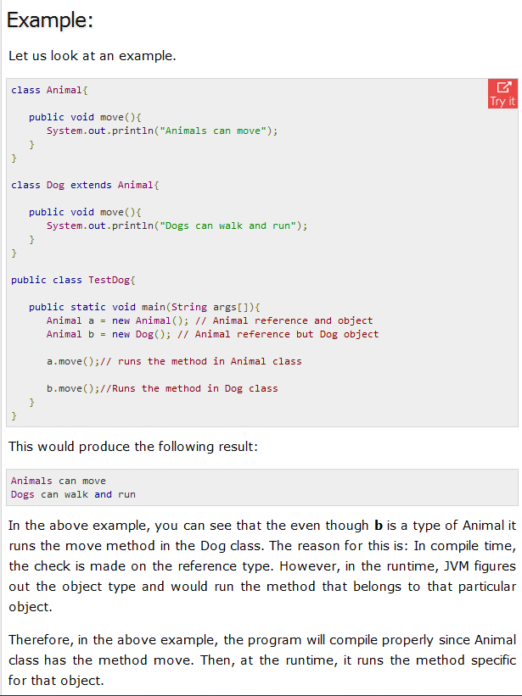

**Final Finally Finalized**

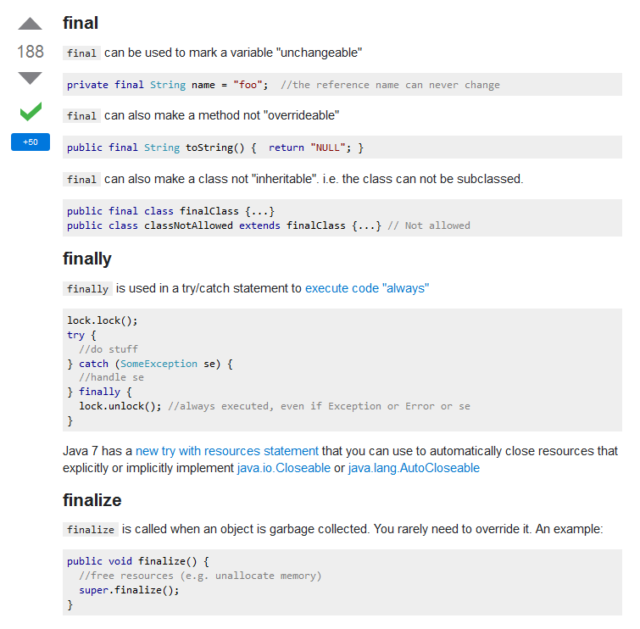

|  |  |  |
| --- | --- | --- |
| 3225 down vote accepted | The stack is the memory set aside as scratch space for a thread of execution. When a function is called, a block is reserved on the top of the stack for local variables and some bookkeeping data. When that function returns, the block becomes unused and can be used the next time a function is called. The stack is always reserved in a LIFO (last in first out) order; the most recently reserved block is always the next block to be freed. This makes it really simple to keep track of the stack; freeing a block from the stack is nothing more than adjusting one pointer.  The heap is memory set aside for dynamic allocation. Unlike the stack, there's no enforced pattern to the allocation and deallocation of blocks from the heap; you can allocate a block at any time and free it at any time. This makes it much more complex to keep track of which parts of the heap are allocated or free at any given time; there are many custom heap allocators available to tune heap performance for different usage patterns.  Each thread gets a stack, while there's typically only one heap for the application (although it isn't uncommon to have multiple heaps for different types of allocation).  To answer your questions directly:  *To what extent are they controlled by the OS or language runtime?*  The OS allocates the stack for each system-level thread when the thread is created. Typically the OS is called by the language runtime to allocate the heap for the application.  *What is their scope?*  The stack is attached to a thread, so when the thread exits the stack is reclaimed. The heap is typically allocated at application startup by the runtime, and is reclaimed when the application (technically process) exits.  *What determines the size of each of them?*  The size of the stack is set when a thread is created. The size of the heap is set on application startup, but can grow as space is needed (the allocator requests more memory from the operating system).  *What makes one faster?*  The stack is faster because the access pattern makes it trivial to allocate and deallocate memory from it (a pointer/integer is simply incremented or decremented), while the heap has much more complex bookkeeping involved in an allocation or free. Also, each byte in the stack tends to be reused very frequently which means it tends to be mapped to the processor's cache, making it very fast. Another performance hit for the heap is that the heap, being mostly a global resource, typically has to be multi-threading safe, i.e. each allocation and deallocation needs to be - typically - synchronized with "all" other heap accesses in the program.  A clear demonstration:  http://i.stack.imgur.com/i6k0Z.png Image source: [vikashazrati.wordpress.com](http://vikashazrati.wordpress.com/2007/10/01/quicktip-java-basics-stack-and-heap/)   |  | | --- | | [share](http://stackoverflow.com/a/80113)[improve this answer](http://stackoverflow.com/posts/80113/edit) | |

**Software Testing**

1. meets the requirements that guided its design and development,responds correctly to all kinds of inputs,
2. performs its functions within an acceptable time,
3. is sufficiently usable,
4. can be installed and run in its intended environments, and
5. achieves the general result its stakeholders desire.

**How to troubleshoot a slow Internet connection**

Slow internet browsing can be very frustrating. It's possible that there is something specific to your location and equipment that is causing the slow down.

**Check your speed**

To figure out whether the lag time you're experiencing is too much:

1. Connect a computer to the modem with an [Ethernet cable](https://www.google.com/search?tbm=isch&q=ethernet+cable&oq=ethernet+cable).

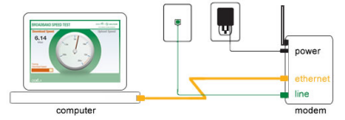

1. Disconnect and power down all devices that access the Internet like other computers, gaming systems, Netflix or other movie streaming devices, DVRs, other routers, switches, VoIP phones, mobile phones and wireless printers.
2. Next, run a speed test and use the table below to figure out if you're getting the speed you should.
   * [CenturyLink Speed Test Tool](http://speedtest.centurylink.com)
   * [Other speed test tools](https://www.google.com/#q=test+my+internet+speed)

Note: Your speed can be affected by changes in network traffic and usage, which will usually vary across days and the time of day. To get the most accurate reading, run the speed test more than once, including different times of the day and different days of the week.

1. Write down the date, time and your results each time you run a test.
2. Compare your results against the table below. Are your speeds lower than or at/above the Target Download Speed?

|  |  |
| --- | --- |
| **Your Connection Speed** | **Target Download Speed (Wired)** |
| 1.5 Mbps | 1.2 Mbps |
| 3 Mbps | 2.4 Mbps |
| 5 Mbps | 4 Mbps |
| 7 Mbps | 5.6 Mbps |
| 12 Mbps | 9.6 Mbps |
| 20 Mbps | 16 Mbps |
| 40 Mbps | 32 Mbps |

1. If your speed test result was **at or above** the Target Download Speed, then you're receiving your subscribed speed. For example, if you've purchased a CenturyLink Internet package with 1.5 Mbps speed, your Target Download Speed shouldn't be lower than 1.2 Mbps.
2. To find out if faster speeds are available where you live:
   * Go to our [high-speed Internet services](http://www.centurylink.com/home/internet/) page.
   * Select the Get Internet Now button for what speeds are available in your area.
   * If faster speeds are not available, scroll to the bottom of the page and click the Notify Me button. We will email you when a faster speed is available where you live.

If the speed test shows your speed is **slower than** the Target Download Speed for your connection, you need to run a second test and check your modem speed.

* + Open up a web browser (Internet Explorer, Firefox, etc.).
  + Type <http://192.168.0.1>* in the address bar, and hit Enter.
  + Select Modem Status and locate the rate (downstream/download or upstream/upload). If you don't see Modem Status, troubleshoot as if your speed test is less than 100%.

1. Still less than the Target Download Speed?
   * [Troubleshooting your modem -- check your cords and cables](http://www.centurylink.com/help/?assetid=192)
   * [Internet & Phone Working Together with Filters](http://www.centurylink.com/help/?assetid=185)
   * [Internet & Phone: How to properly connect a landline phone through the same wall phone jack as the modem](http://www.centurylink.com/help/?assetid=192#phonetomodem)

Lastly, bad wiring can cause slow connections. To figure out if the problem is inside or outside your house, [test your service at the Network Interface Device (NID)](http://internethelp.centurylink.com/internethelp/wired-dmarc.html).

**Still haven't found the problem?**

If your modem, filters and cables are installed correctly, it's possible your web browser isn't working superiorly, your wireless connection is partially blocked, a virus has found its way onto your computer and/or equipment is malfunctioning.

* If you haven't cleared your cache lately, your web browser may be bogged down and [cleaning it out](http://www.centurylink.com/help/?assetid=242#webbrowser) might speed up your connection.
* If you're using a wireless network, read [Improve the performance of your wireless connection](http://www.centurylink.com/help/?assetid=190) for quick troubleshooting ideas.
* If you have any reason to believe you have a virus, read [Keep your computer healthy with PC diagnostic and security scans](http://www.centurylink.com/help/?assetid=252) for how to check for viruses and how to remove them.
* If your modem is the oldest piece of networking equipment you have, it might be time to change it out. Old modems can slow down your connection speed.

If none of these things resonate with you, a [PC Health Check](https://centurylinkrc.com/AtEase/)* might reveal some useful information. There is no cost to run a health check on your computer. The service is secure and takes about 7 minutes to complete. While the service is running, you can chat with an agent at any time by opening the LogMeInRescue window. When the health check is finished, you'll get a list of recommendations for what you can do next.

If you'd prefer to simply ask someone some questions, [chat with us](http://www.centurylink.com/help/chat/?team1=tech). We're here to help.

**Did you know?**

* The way a website is built or the equipment the website owner uses has a direct affect on the speed with which you experience a particular website or web page.
* Also, the amount of traffic on the internet can cause the speed of your service to vary. This is similar to a freeway you drive your car on. You may have a very fast car, but if the traffic on the freeway is slow, it is going to affect how fast your car can go. It has the same affect on your browsing experience.

Domain Name Servers (**DNS**) are the Internet's equivalent of a phone book. They maintain a directory of domain names and translate them to Internet Protocol (IP) addresses. This is necessary because, although domain names are easy for people to remember, computers or machines, access websites based on IP addresses.

The 500 Internal Server Error is a very general [HTTP status code](http://pcsupport.about.com/od/termshm/g/httpstatuscode.htm) that means something has gone wrong on the web site's server, but the server could not be more specific on what the exact problem is.

**Are You the Webmaster?** See Fixing 500 Internal Server Error Problems on Your Own Site towards the bottom of the page for some better advice if you're seeing the 500 Internal Server Error on one or more of your own pages.

The 500 Internal Server Error message might be seen in any number of ways because each website is allowed to customize the message.

Here are several common ways that you might see the HTTP 500 error:

### How You Might See a 500 Error

* **"500 Internal Server Error"**
* **"HTTP 500 - Internal Server Error"**
* **"Temporary Error (500)"**
* **"Internal Server Error"**
* **"HTTP 500 Internal Error"**
* **"500 Error"**
* **"HTTP Error 500"**
* **"500. That's an error"**

Since a 500 Internal Server Error is generated by the website you're visiting, you could see one in any browser in any [operating system](http://pcsupport.about.com/od/termshm/g/term_os.htm), even on your smartphone.

Most of the time, a 500 Internal Server Error displays inside the Internet browser window, just as web pages do.

continue reading below our video

How to Fix Browser Error Codes

Play

0:00

/

0:00

Fullscreen

Mute

### Cause of HTTP 500 Errors

As I mentioned above, Internal Server Error messages indicate that something, in general, is wrong.

Most of the time, "wrong" means an issue with the page or site's programming, but there's certainly a chance the problem is on your end, something we'll investigate below.

**Note:** More specific information about the cause of a particular HTTP 500 error is often provided when it occurs on a server using Microsoft IIS software.

Look for numbers after 500 as in **HTTP Error 500.19 - Internal Server Error** which means **Configuration data is invalid**. See More Ways You Might See an Internal Server Error below for the complete list.

### How To Fix the 500 Internal Server Error

Like I alluded to above, the 500 Internal Server Error is a server-side error, meaning the problem probably isn't with your computer or Internet connection but instead is a problem with the web site's server.

While not probable, it is possible that there's something wrong on your end and we'll look at some things you can try.

1. Reload the web page. You can do that by clicking the refresh/reload button, pressing **F5**, or trying the [URL](http://pcsupport.about.com/od/termsu/g/termurl.htm) again from the address bar.  
     
   Even if the 500 Internal Server Error is a problem on the web server, the issue may only be temporary. Trying the page again will often be successful.  
     
   **Note:** If the 500 Internal Server Error message appears during the checkout process at an online merchant, be aware that duplicate attempts to checkout may end up creating multiple orders - and multiple charges! Most merchants have automatic protections from these kinds of actions, but it's still something to keep in mind.

[Ads](http://pcsupport.about.com/od/findbyerrormessage/a/500servererror.htm)

* [PC Browser](http://pcsupport.about.com/z/js/o.htm?k=pc%20browser&SUName=pcsupport&d=PC%20Browser&r=http%3A%2F%2Fpcsupport.about.com%2Fod%2Ffindbyerrormessage%2Fa%2F500servererror.htm)
* [PC Server](http://pcsupport.about.com/z/js/o.htm?k=pc%20server&SUName=pcsupport&d=PC%20Server&r=http%3A%2F%2Fpcsupport.about.com%2Fod%2Ffindbyerrormessage%2Fa%2F500servererror.htm)
* [502 Error](http://pcsupport.about.com/z/js/o.htm?k=502%20error&SUName=pcsupport&d=502%20Error&r=http%3A%2F%2Fpcsupport.about.com%2Fod%2Ffindbyerrormessage%2Fa%2F500servererror.htm)
* [Managed Server](http://pcsupport.about.com/z/js/o.htm?k=managed%20server&SUName=pcsupport&d=Managed%20Server&r=http%3A%2F%2Fpcsupport.about.com%2Fod%2Ffindbyerrormessage%2Fa%2F500servererror.htm)
* [PC Help](http://pcsupport.about.com/z/js/o.htm?k=pc%20help&SUName=pcsupport&d=PC%20Help&r=http%3A%2F%2Fpcsupport.about.com%2Fod%2Ffindbyerrormessage%2Fa%2F500servererror.htm)

1. [Clear your browser's cache](http://pcsupport.about.com/od/browsers/f/clear-cache.htm). If there's a problem with the cached version of the page you're viewing, it could be causing HTTP 500 issues.  
     
   **Note:** Internal Server Errors are not often caused by caching issues, but I have, on occasion, seen the error go away after clearing the cache. It's such an easy and harmless thing to try so don't skip it.
2. [Delete your browser's cookies](http://pcsupport.about.com/od/browsers/f/delete-cookies.htm). Some 500 Internal Server Error issues can be corrected by deleting the cookies associated with the site you're getting the error on.  
     
   After removing the cookie(s), restart the browser and try again.
3. Troubleshoot as a [504 Gateway Timeout](http://pcsupport.about.com/od/findbyerrormessage/a/504error.htm) error instead.  
     
   It's not very common, but some servers produce a 500 Internal Server Error when in reality a more appropriate message based on the cause of the problem is 504 Gateway Timeout.
4. Contacting the website directly is another option. Chances are good the site's administrators already know about the 500 error but if you suspect they don't, letting them know helps both you and them (and everyone else).  
     
   See my [Website Contact Information](http://pcsupport.about.com/od/resources/tp/website-contact-information.htm) list for contact information for popular websites. Most sites have support-based social network accounts and a few even have email and telephone numbers.  
     
   **Tip:** If it looks like the site is down completely and you can't find a way to report the 500 Internal Server Error message to the website, it might help your sanity to keep up with the outage on Twitter. You can usually do this by searching for #websitedown on Twitter, as in [#gmaildown](https://twitter.com/search?q=%23gmaildown) or [#facebookdown](https://twitter.com/search?q=%23facebookdown).
5. Come back later. Unfortunately, at this point, the 500 Internal Server Error is no doubt a problem outside your control that will eventually get fixed by someone else.  
     
   If the 500 Internal Server Error message is appearing at check out during an online purchase, it might help to realize that sales are probably being disrupted - usually a great incentive to the online store to fix the issue very quickly!  
     
   Even if you're getting the 500 error on a site that doesn't sell anything, like YouTube or Twitter, as long as you've let them know about the problem, or at least tried, there's little more you can do than wait it out.

### Fixing 500 Internal Server Error Problems on Your Own Site

A 500 Internal Server Error on your own website requires a completely different course of action. As I mentioned above, most 500 errors are server-side errors, meaning it's likely your problem to fix if it's your website.

There are lots of reasons why your site might be serving a 500 Error to your users, but two are most common:

* **A Permissions Error.** In most cases, a 500 Internal Server Error is due to an incorrect permission on one or more files or folders. In most of those cases, an incorrect permission on a PHP and CGI script is to blame. These should usually be set at 0775 (-rwxr-xr-x).
* **A PHP Timeout.** If your script connects to external resources and those resources timeout, an HTTP 500 error can occur. Timeout rules, or better error handling in your script, should help if this is the cause of the 500 error.
* **A Coding Error in .htaccess.** While not as common, be sure to check that your site's [.htaccess file](http://pcsupport.about.com/od/fileextensions/f/htaccess-file.htm) is properly structured.

If you're running [WordPress](https://wordpress.org/support/), [Joomla](http://www.joomla.org/), or another content management or CMS system, be sure to search their support centers for more specific help troubleshooting a 500 Internal Server Error.

If you're not using an off-the-shelf content management tool, your web hosting provider, like [InMotion](http://www.inmotionhosting.com/support/website/error-numbers/500-internal-server-error), [Dreamhost](http://wiki.dreamhost.com/Advanced_Troubleshooting_Techniques), [Bluehost](https://my.bluehost.com/cgi/help/594), [1&1](http://help.1and1.com/hosting-c37630/scripts-and-programming-languages-c85099/php-c37728/explanation-of-500-errors-a595888.html), etc., probably has some 500 Error help that might be more specific to your situation.

### More Ways You Might See an Internal Server Error

In Internet Explorer, the message **The website cannot display the page** often indicates an HTTP 500 Internal Server Error. A 405 Method Not Allowed error is another possibility but you can be sure by looking for either 500 or 405 in the IE title bar.

When Google services, like Gmail or Google+, are experiencing a 500 Internal Server Error, they often report a Temporary Error (500) or simply 500.

When [Windows Update](http://pcsupport.about.com/od/keepingupwithupdates/p/windows-update.htm) reports an Internal Server Error, it appears as a WU_E_PT_HTTP_STATUS_SERVER_ERROR message or as the 0x8024401F error code.

If the website that reports the 500 error is running Microsoft IIS, you may get a more specific error message:

**Thread**

Multithreading refers to two or more tasks executing concurrently within a single program. A **thread** is an independent path of execution within a program. Many **threads** can run concurrently within a program. Every **thread** in **Java** is created and controlled by the **java**.lang.**Thread** class.